MySQL Database Setup

REGISTRY DATABASE
MySQL is an open-source relational database management system (RDBM) that stores data on disk by default (note: it is not an in-memory database). MySQL uses a client-server architecture requiring a dedicated database server. It allows multiple users to access and manage the data simultaneously.
Purpose: We want to use it as a permanent registry of the HSML Entities, in which we store the SWID (the DID public key) and the Entities metadata in HSML JSON files. This database would be used as a verification mechanism as it would contain all the HSML Entities identities and their connections to others. This way we can identify the users (Person type) and the Organizations they belong to, the Agents and their owners (Domain Authorities), the Hyperspaces they occupy, which Agents have Credentials associated to them and who has therefore access, the Contracts associated to Activities…
Why MySQL is the best option for Verification:
- Ideal for long-term, structured storage
- Supports JSON (files) columns & for multiple users to access/manage data simultaneously
- Supports complex SQL queries for metadata filtering & verification

My Local Setup:
- Windows Service Name: MySQL80
- Username: root
- MySQL root password: MoonwalkerJPL85!
- Using MySQL Workbench (a GUI tool for MySQL)
- Database name: did_registry
- Table name: did_keys
NOTE: These names can be changed but remember to go in the codes and then change these accordingly.

How to create the MySQL Database and Table:
To create the Database:
CREATE DATABASE did_registry;
USE did_registry;
Now, all subsequent commands will apply to did_registry
So, to create our Table:
CREATE TABLE did_keys (
id INT AUTO_INCREMENT PRIMARY KEY,
did VARCHAR(255) UNIQUE NOT NULL,
registered_by VARCHAR(255) DEFAULT NULL,
public_key TEXT NOT NULL,
metadata JSON,
created_at TIMESTAMP DEFAULT CURRENT_TIMESTAMP,
kafka_topic VARCHAR(255) DEFAULT NULL,
allowed_did TEXT DEFAULT NULL
);

Explanation of each column header name:
- id – row number (1,2,3,…) automatically generated
- did – The SWID of the Entity being registered (did:key:xyz123…)
- registered_by – The SWID of the Person/Organization registering an Entity
- public_key – Just the public key part (xyz123…) because may be useful
- metadata – HSML json file with main properties
- created_at – timestamp of when the key was created, automatically stores it
- kafka_topic – Name of the Kafka topic associated with an Agent
- allowed_did – List of SWIDs accepted to subscribe to the topic of that Agent (these have been added through Credentials

Other Useful Commands:
- To open MySQL shell:
mysql -u root -p
- To switch to SQL mode:
\sql
- To check if table created successfully:
SHOW TABLES;
- To check table’s structure:
DESCRIBE did_keys;
- To check table structure, column names:
DESC did_keys;
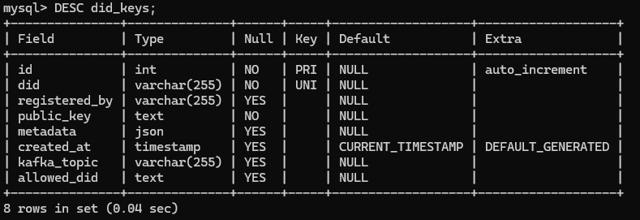
- To manually add a value/entry inside a cell of a row that already exists:
UPDATE did_keys
SET kafka_topic = ‘example_agent’
WHERE id = 4;
- To verify the update:
SELECT * FROM did_keys WHERE id=4;
- To manually insert a new row:
INSERT INTO did_keys (id, did, kafka_topic)
VALUE (123, ‘did:key:xyz123…’, ‘my_kafka_topic_name’;
- To add a new column to the table (NOTE: run “USE did_registry;”; first in mysql)
ALTER TABLE did_keys ADD COLUMN registered_by VARCHAR(255) DEFAULT NULL;
- To show the new columns filled in mysql:
SELECT * FROM did_keys;
- To exit mysql:
EXIT;

